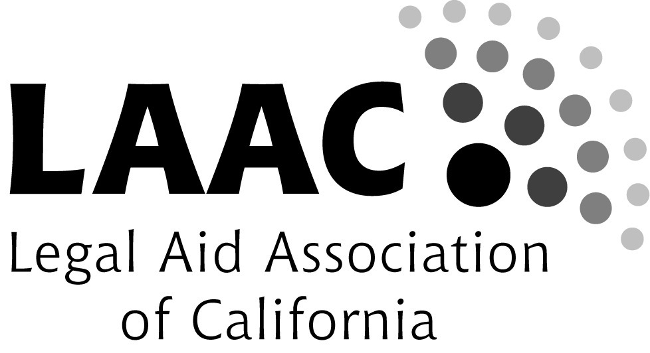

Do you know a Legal Services Attorney, Pro Bono Attorney, or Court Staff working in the field of Family Law
who deserves recognition for his or her work?

The Legal Aid Association of California invites you to nominate him or her for the
2017 LAAC Family Law Awards!

Nomination Deadline: FRIDAY, May 26, 2017

This year’s awards will be presented at the 2017 Family Law and Self-Help Conference,
presented by the Judicial Council and the Legal Aid Association of California.

July 24, 2017
California Endowment Center
1000 Alameda St,
Los Angeles, CA 90012

The 2017 LAAC Family Law Awards will be presented to three family law advocates in recognition of their outstanding dedication and commitment to legal services for low-income Californians. One award will be given to an advocate who has demonstrated exemplary service to low-income clients in family law in each of the following categories:
- Direct representation (Legal Services Family Attorney)
- Pro Bono Work (Private Attorney)
- Family Law Facilitator or Self-Help Center Service Provider

The Legal Aid Association of California (LAAC), the statewide membership organization of legal services nonprofits, serves and strengthens its members through advocacy, training, and support in their efforts to provide critical legal assistance to low-income Californians and ensure equal access to justice.

All LAAC organizational members, individual supporters, and members of the
LAAC Family Law Conference Planning Committee are eligible to make award nominations.
Want to learn more about becoming an organizational member or individual supporter?
Visit http://laaconline.org/members/benefits/
2017 LAAC Family Law Awards – Nomination Form
Nomination Category – Please check one:
- Direct representation (Legal Services Family Attorney)
- Pro Bono Work (Private Attorney)
- Family Law Facilitator or Self-Help Center Service Provider

(1) Nominee’s Information
Nominee's Name: ______________________________________________________________________
Organization/Firm/Court: ________________________________________________________________
Address: _____________________________________________________________________________
Telephone: _______________________ Fax: _______________________
E-mail: ______________________________________________________

(2) Nominator’s Information
Nominator: ___________________________________________________________________________
Organization/Firm/Court: _______________________________________________________________
Address: ____________________________________________________________________________
Telephone _________________________ Fax: ______________________
E-mail: ______________________________________________________

(3) Statement Supporting the Nomination: Please attach a brief statement (no longer than 2 pages) explaining why your nominee qualifies for an award. It is helpful to specifically address the nomination criteria for the category for which you are nominating him/her and to give a brief overview of the nominee’s work history, other activities, or other recognition that they have received. You may also include a resume and up to two letters of support. The additional materials are very helpful to the selection committee members. As always, thank you for your thoughtful nomination!

The LAAC Recognition Committee will consider the nominee's contributions in one or more of the following areas:

- Demonstrated commitment to the delivery of direct legal services to the poor in family law;
- Successful cases that had a significant impact on legal services family law clients;
- Work with the family law client community that increased client access to legal services;
- Activity that enhanced the delivery of legal services to family law clients.

Send completed forms and
supplementary information to:
Lorin Kline
Program Attorney
Legal Aid Association of California (LAAC)
lkline@laaconline.org

Questions? Contact Lorin Kline
at (510) 893-3000 x 105

